**INTI International College Penang School of Engineering and Technology**

**3+0 Bachelor of Science (Hons) in Computing, in collaboration with Coventry University, UK**

**Coursework cover sheet**

**Section A - To be completed by the student**

|  |  |
| --- | --- |
| Full Name: CHAI YI BING | |
| CU Student ID Number: P21013721 | |
| Semester: 3 | |
| Session:**April 2022** | |
| Lecturer:  **Nadhrah Abdul Hadi (nadhrah.abdulhadi@newinti.edu.my)** | |
| Module Code and Title:  **4067CEM Software Design** | |
| Assignment No. / Title:  **Continuous Assessment** | % of Module Mark:  **50** |
| Hand out Date:  **22nd April 2022** | Due Date:  **Task 1: 13 May 2022, by 11.59pm**  **Task 2: 1 July 2022, by 11.59pm**  **Task 3: 17 June 2022, by 11.59pm.**  **Task 4: 17 June 2022, by 11.59pm.**  **Task 5: 17 June 2022, by 11.59pm.** |
| Penalties: No late work will be accepted. If you are unable to submit coursework on time due to extenuating circumstances, you may be eligible for an extension. Please consult the lecturer. | |
| Declaration: I/we the undersigned confirm that I/we have read and agree to abide by the University regulations on plagiarism and cheating and Faculty coursework policies and procedures. I/we confirm that this piece of work is my/our own. I/we consent to appropriate storage of our work for plagiarism checking.  Signature(s): __________ Bing ______________ | |

**Section B - To be completed by the module leader**

|  |  |  |
| --- | --- | --- |
| Intended learning outcomes assessed by this work:  1. Understand and apply appropriate concepts, tools and techniques to each stage of the software development  2. Understand and apply design patterns to software components in developing new software  3. Demonstrate an understanding of project planning and working to agreed deadlines, along with professional, interpersonal skills and effective communication required for software production  5. Demonstrate an awareness of, and ability to apply, social, professional, legal and ethical standards as documented in relevant laws and professional codes of conduct such as that of the Malaysian National Computer Confederation. | | |
| Marking scheme | Max | Mark |
| 1. User Story Mapping 2. Setting up a GitHub Repository 3. Creating a Class diagram and design pattern selection 4. Creating a Prototype User Interface and Usability Testing 5. Discuss the ethical issue related to the software | 20  10  30  20  20 |  |
| Total | 100 |  |

**Task 4: Creating a Prototype and Usability Testing**

**Prototype**

Question 1: How can we log in when we don’t have an account?

Question 2: If we already have an account how can we log in?

Sign Up-Input detail-Verify captcha

Log IN Page 1

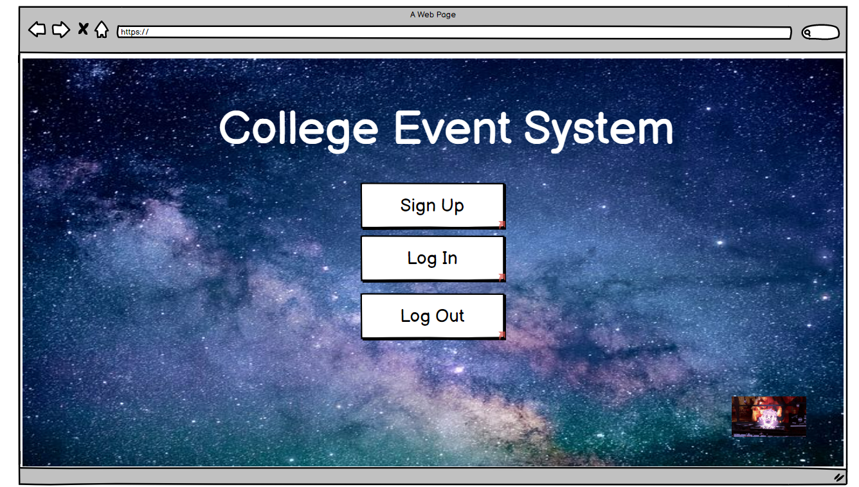

Log In Page 2

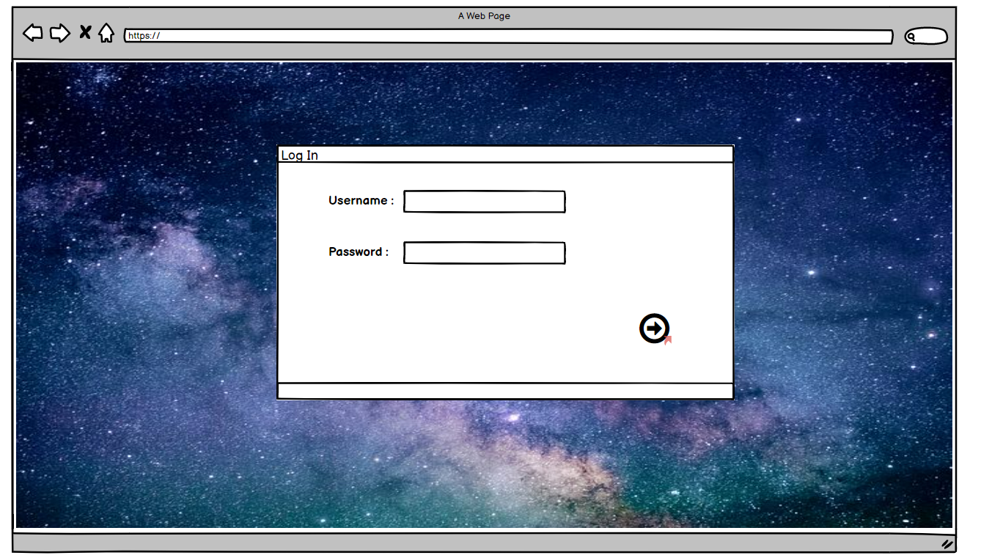

Log in Page 3 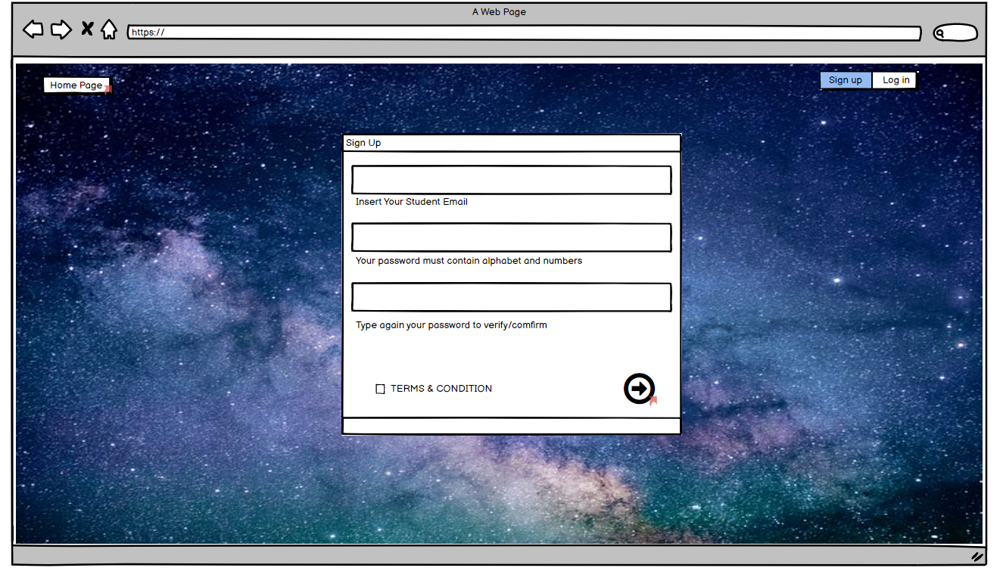

Log In Page 4 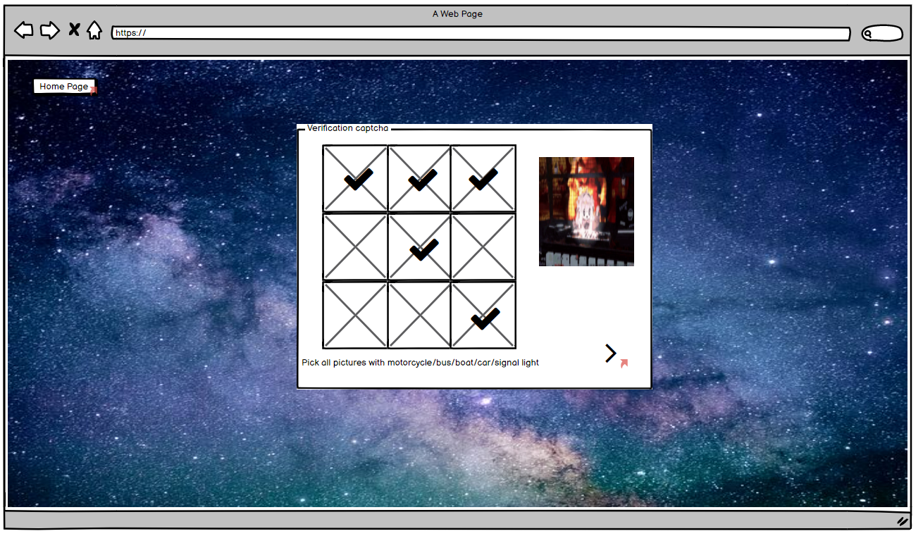

Above is the screen shot of my first main function which is the log in/ sign up function. The picture in both 1st page of log in and verify captcha is some place to put the picture of the school or advertisement if needed.

Log in Page 5

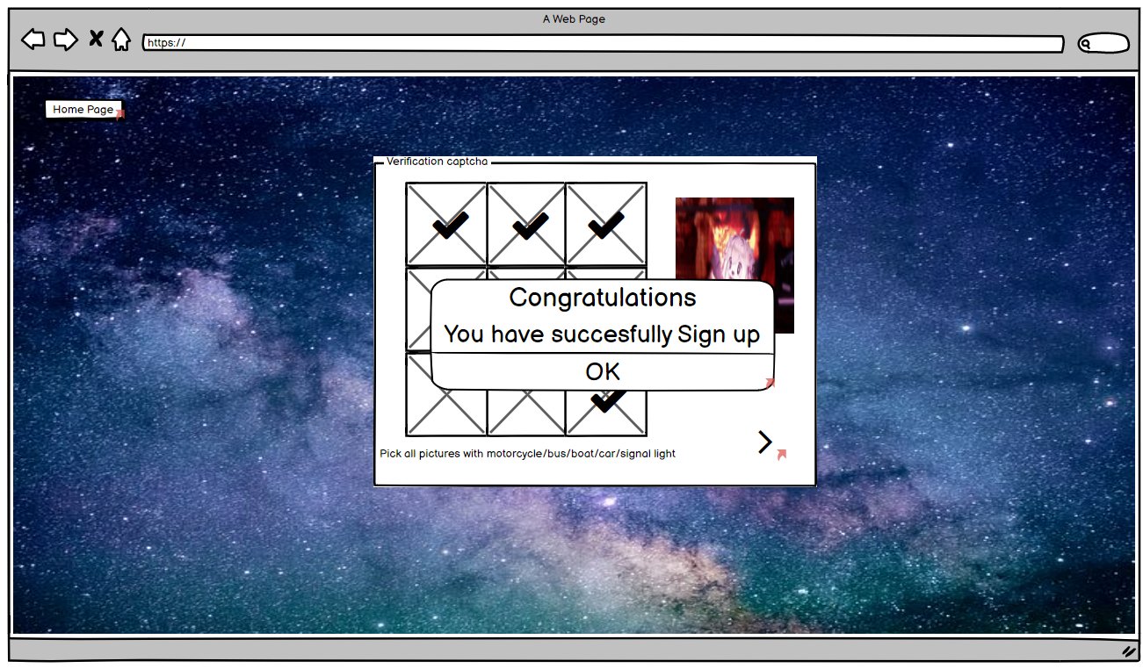

Here it will pop out a message to show that user has successfully register an account.

Question 3: Where to find the event page?

Question 4: Where to find more info of history of event?

Question 5: Where can I have a look in more picture of the events?

Question 6: How can we see upcoming event?

Question 7: How can we log out of the page?

Question 8: How can we update or edit the event?

Question 9: How can we search by category?

Question 10: If we want to watch or comment on some event where can we go?

Question 11: How to go to Setting?

Home page for Events

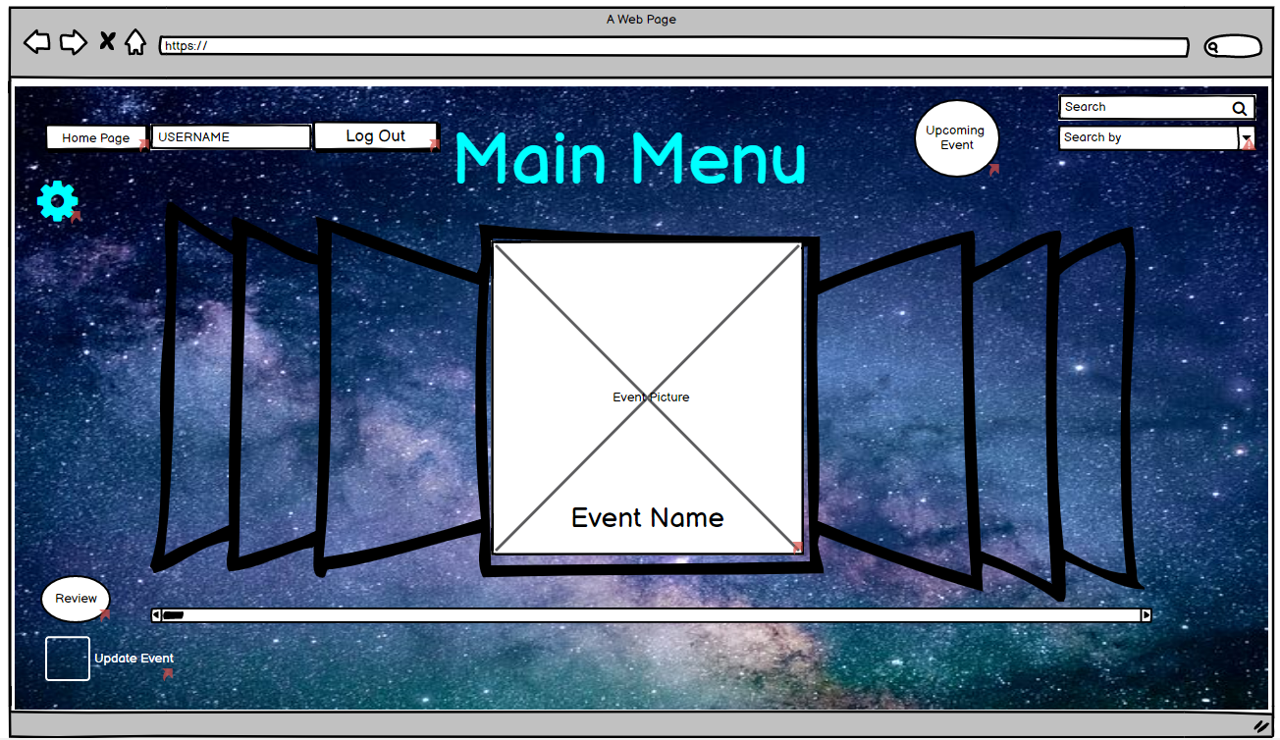

From this page we can view event pic event name and can select the event by clicking the picture. Other then that, we can also go to Upcoming event and review. This would be my second main function.

Event Page 1

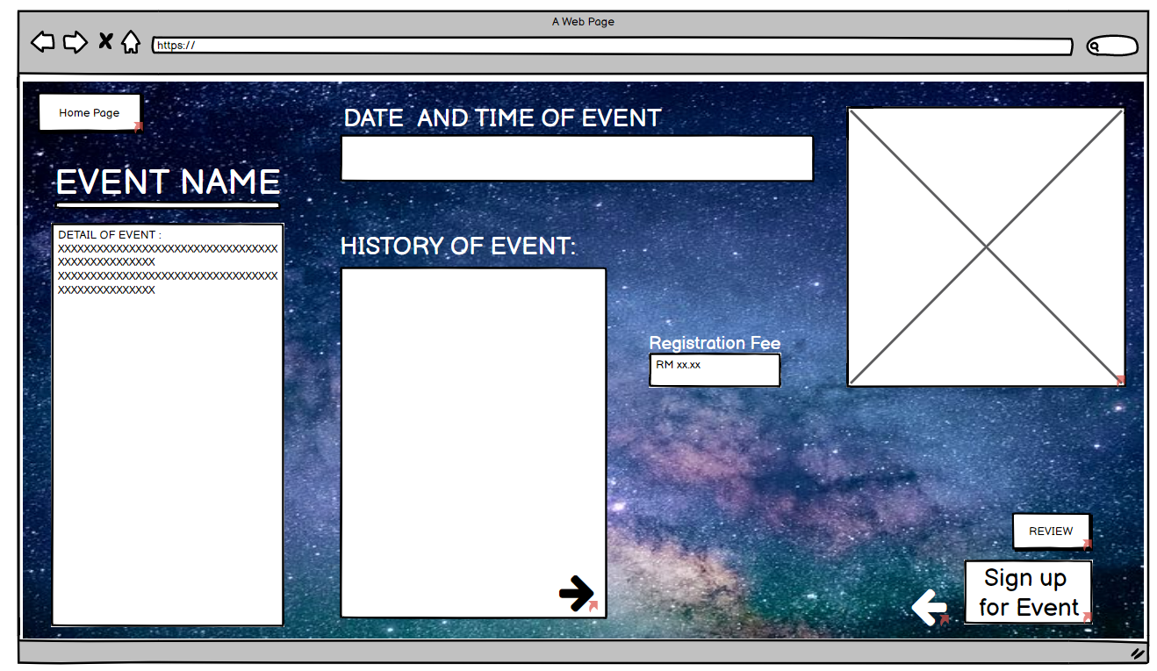

Here is the page that will come out when select an event.

Event Page 2

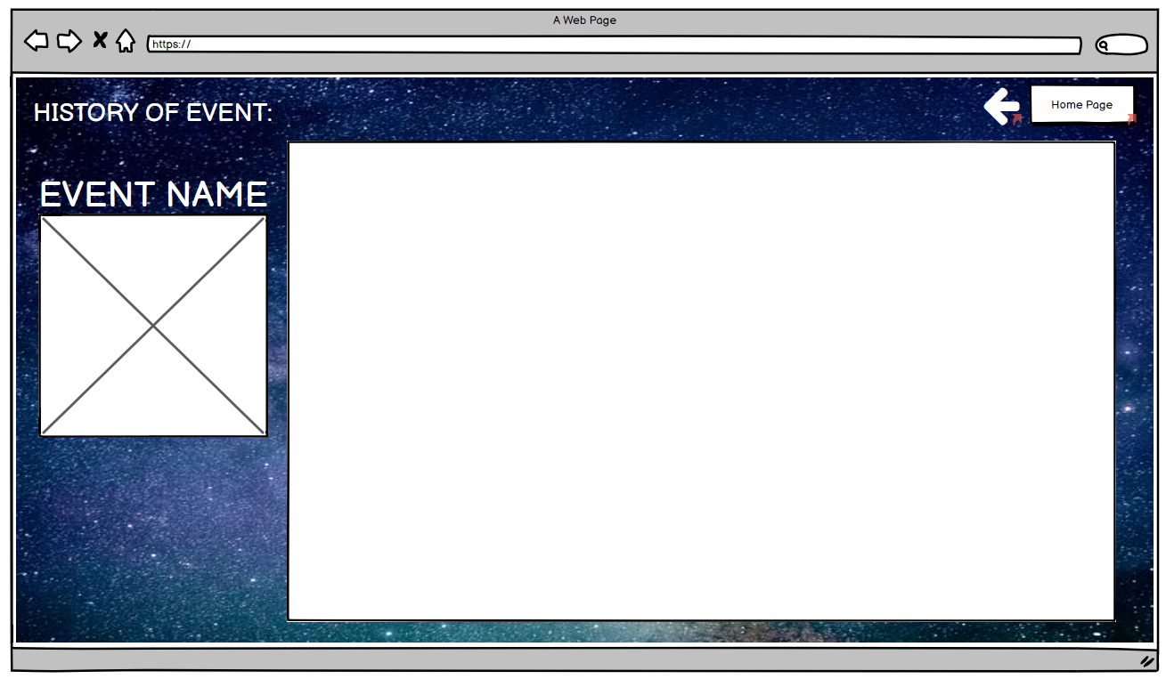

Here is another page for history of event is if the user want to know more info about the history of event.

Event page 3 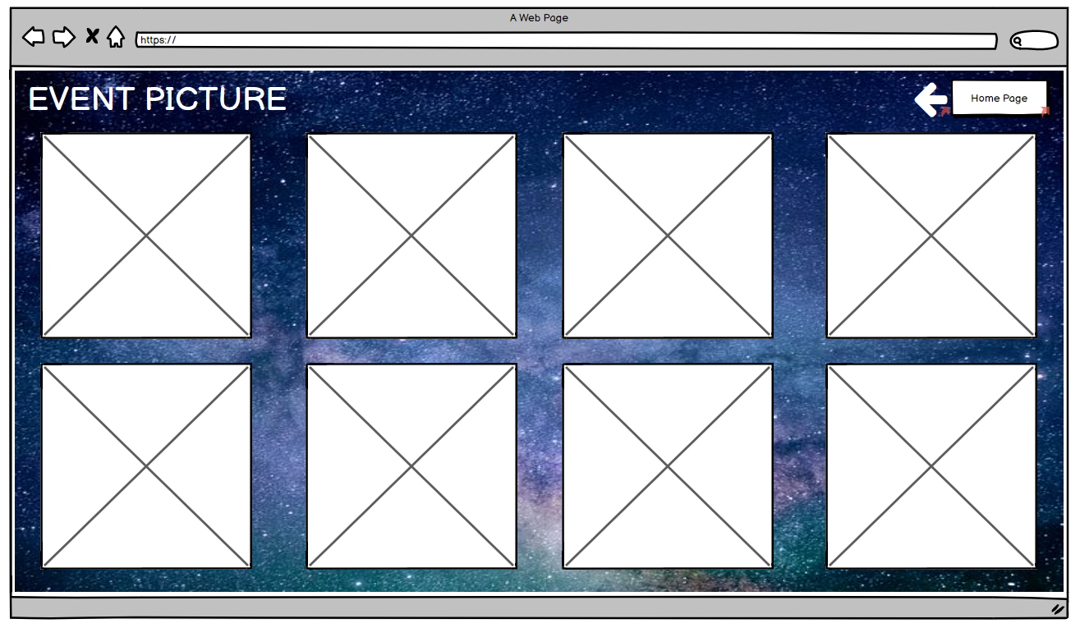

Here is the page of Event picture also can be access by the event 1st page.

Update/ Edit page

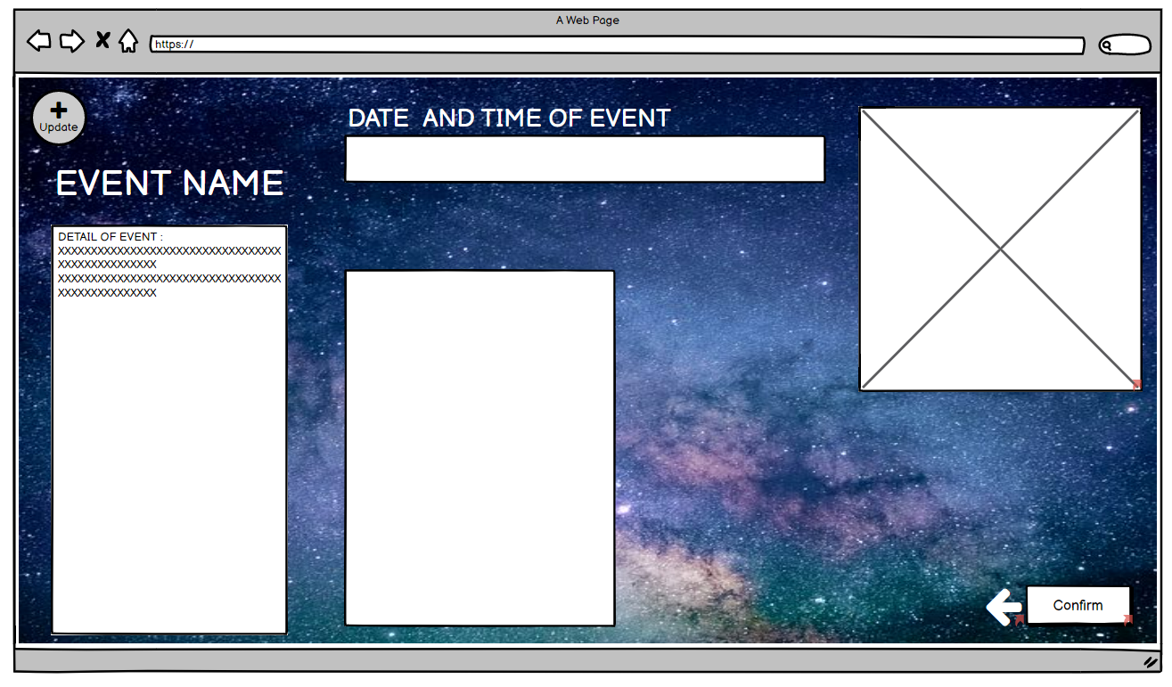

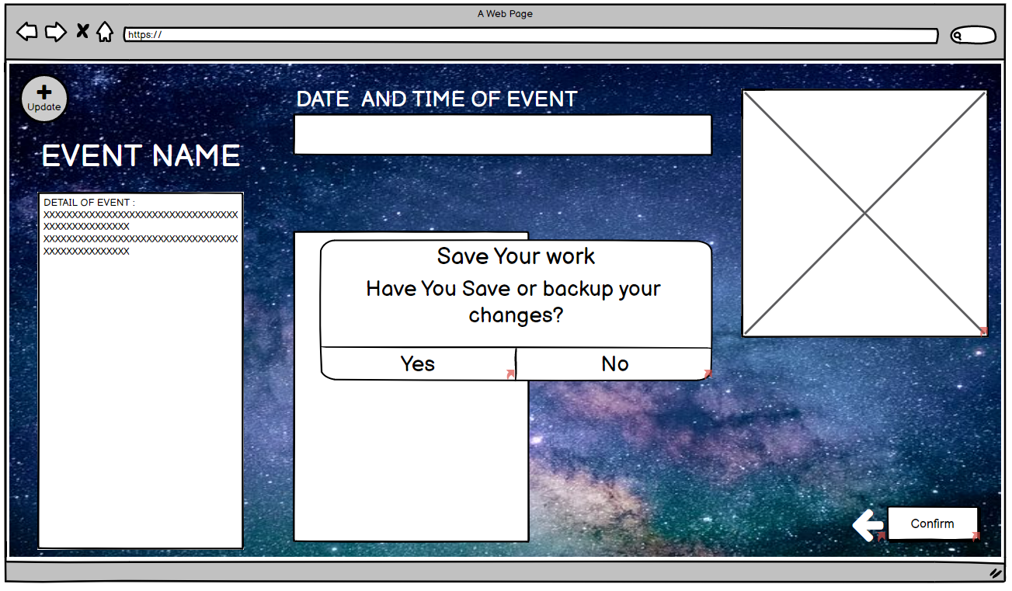

These two pages is the page where we edit and update the page and save the changes pop out message.

Setiing page

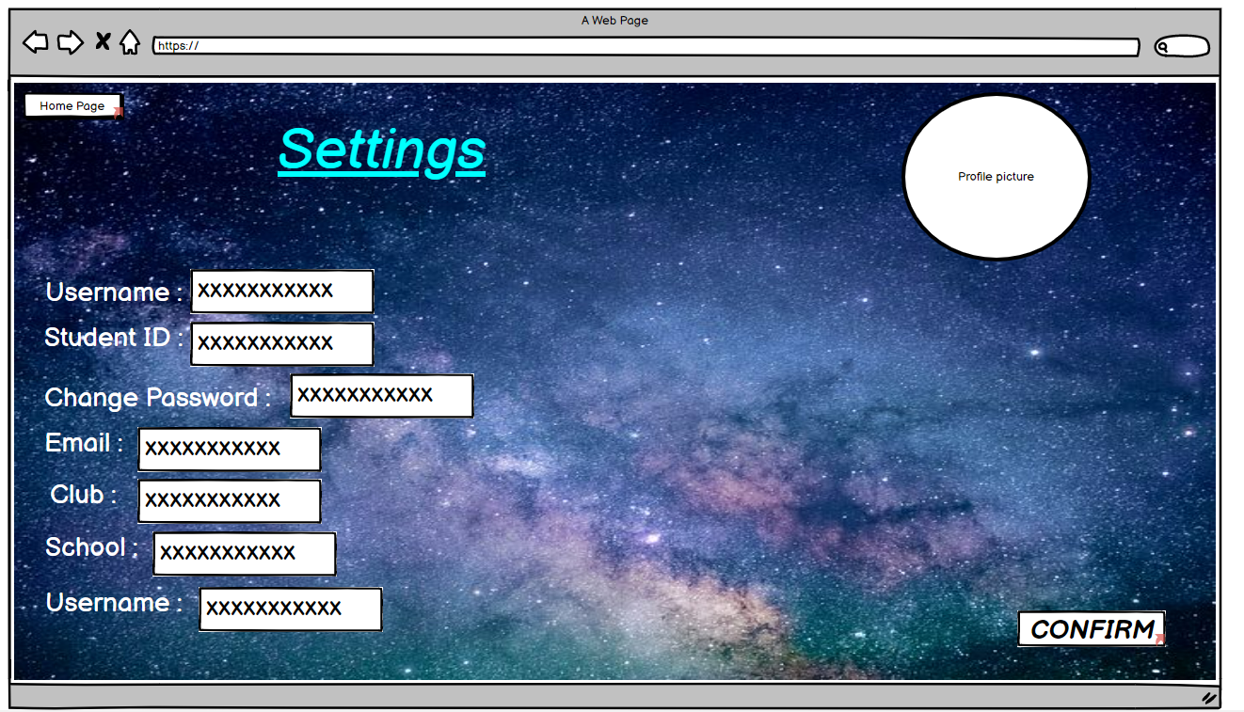

Upcoming Events page

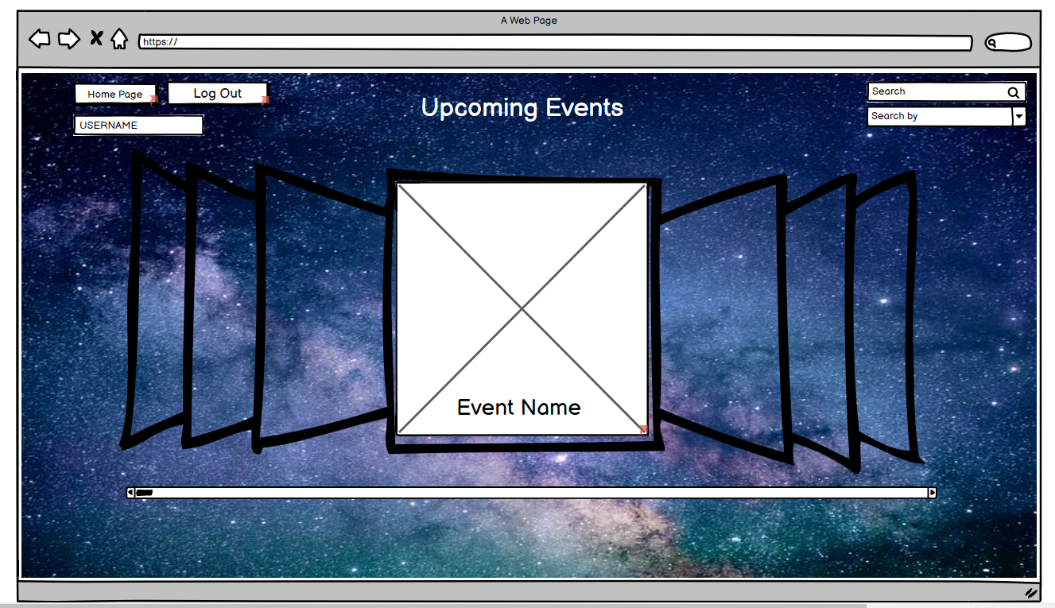

Log out Pop out page

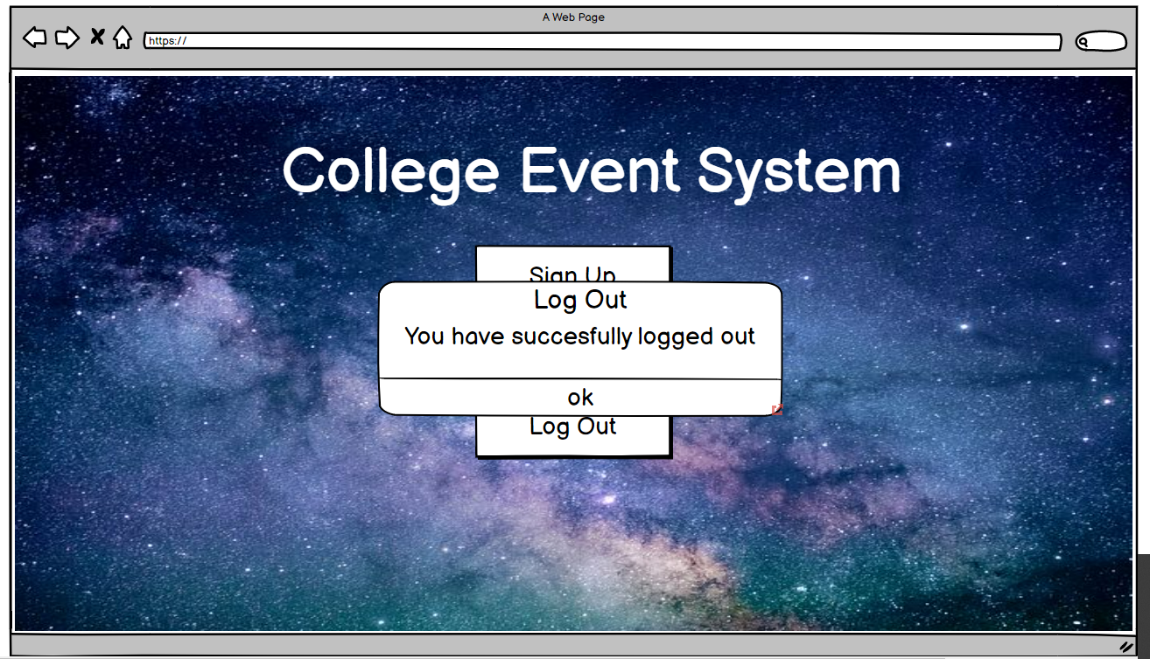

Search by category page

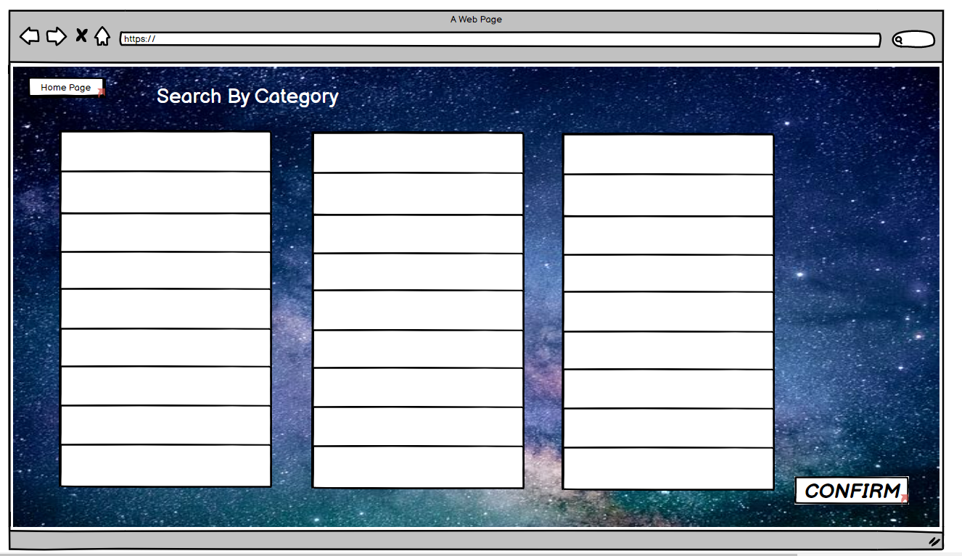

Search by event page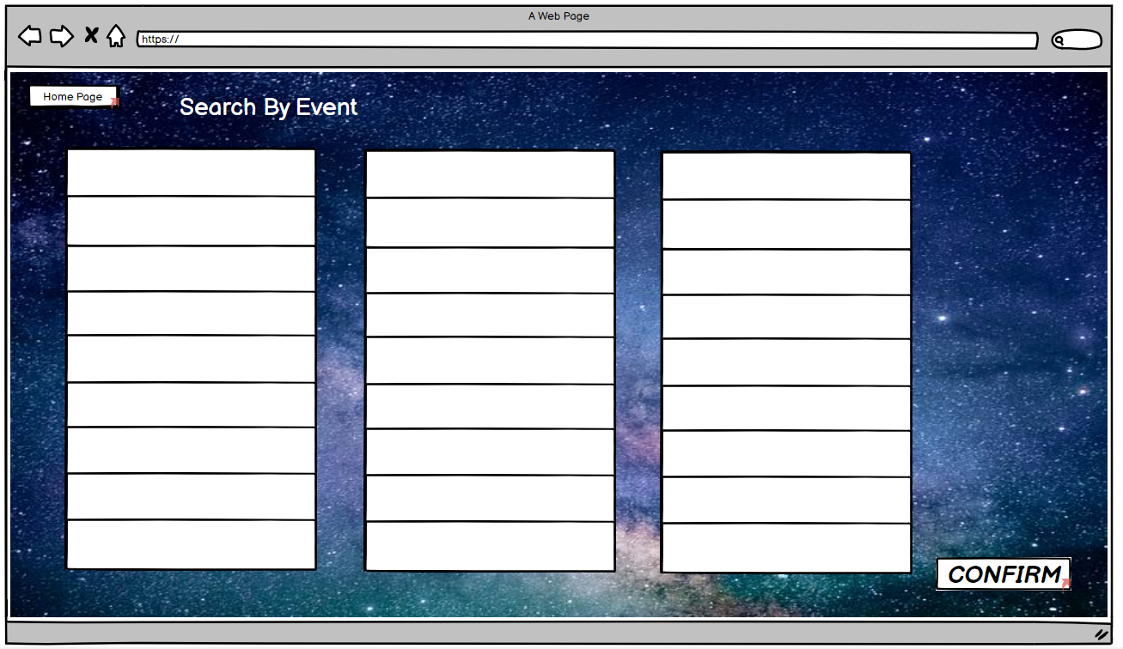

Search by School page

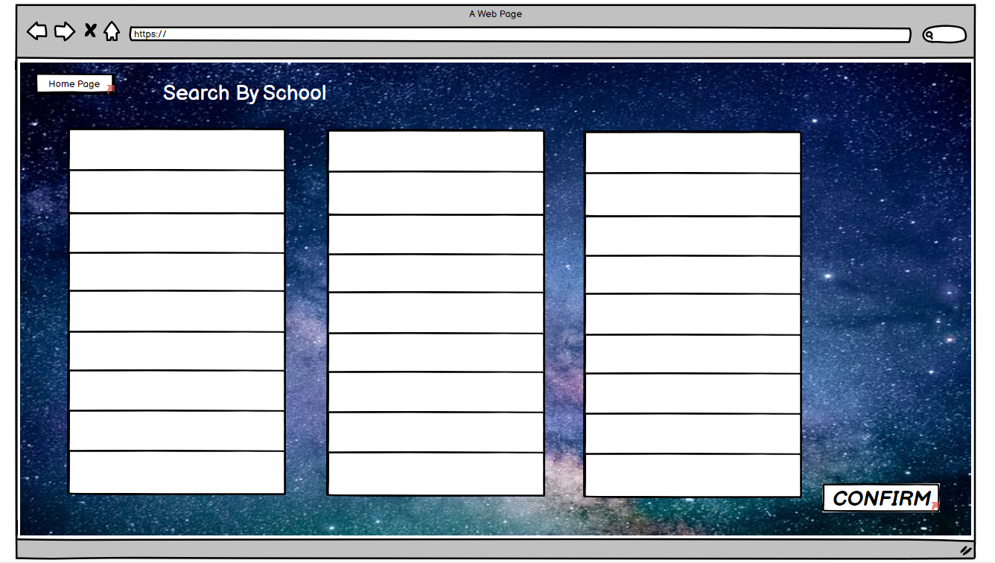

Search by Name page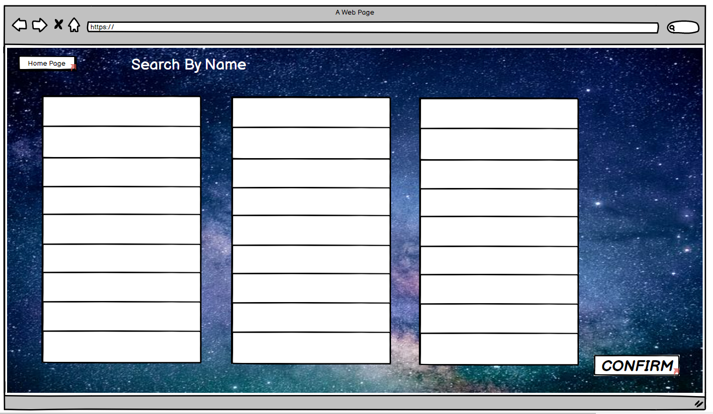

Search by Club page

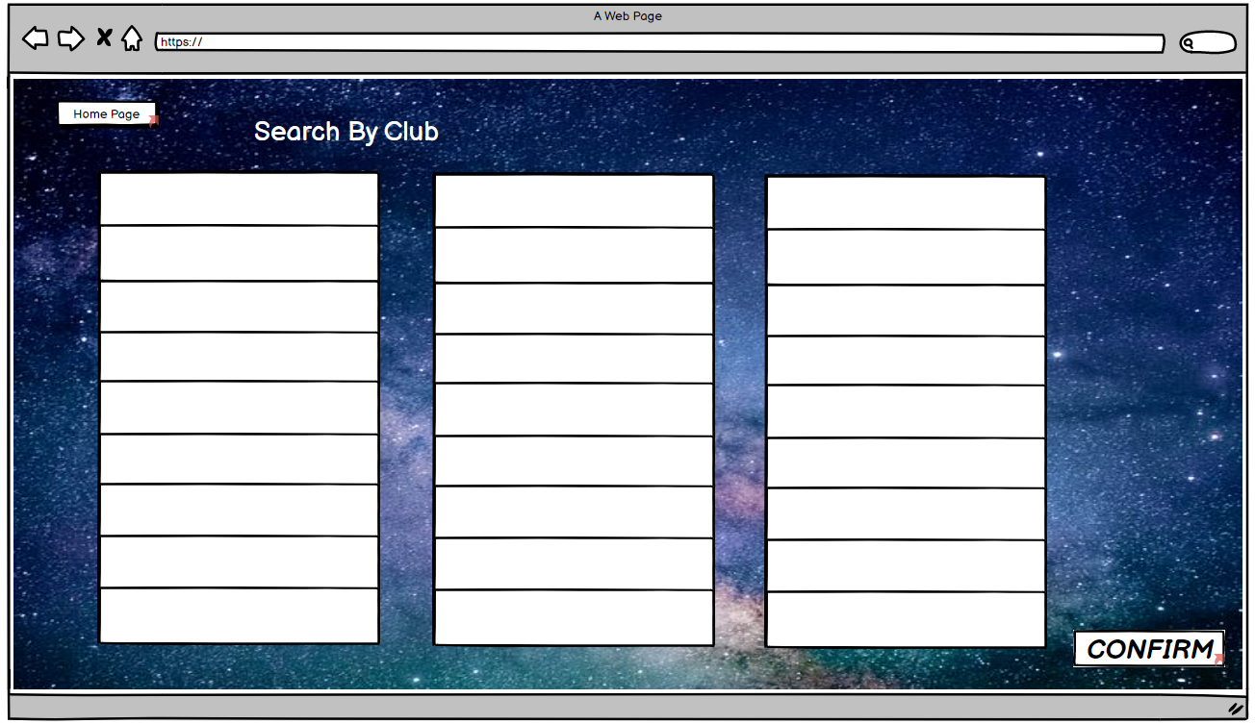

Registration Page

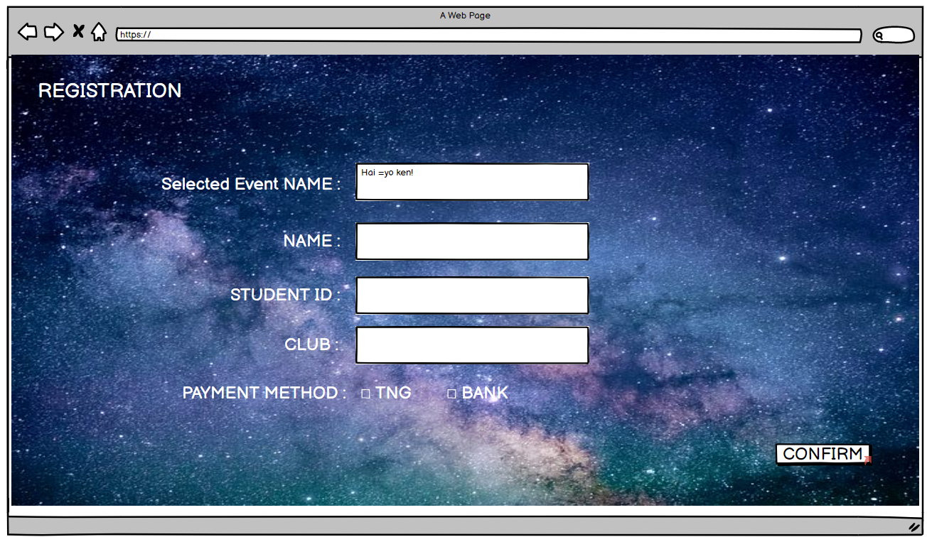

Registration pop out Page

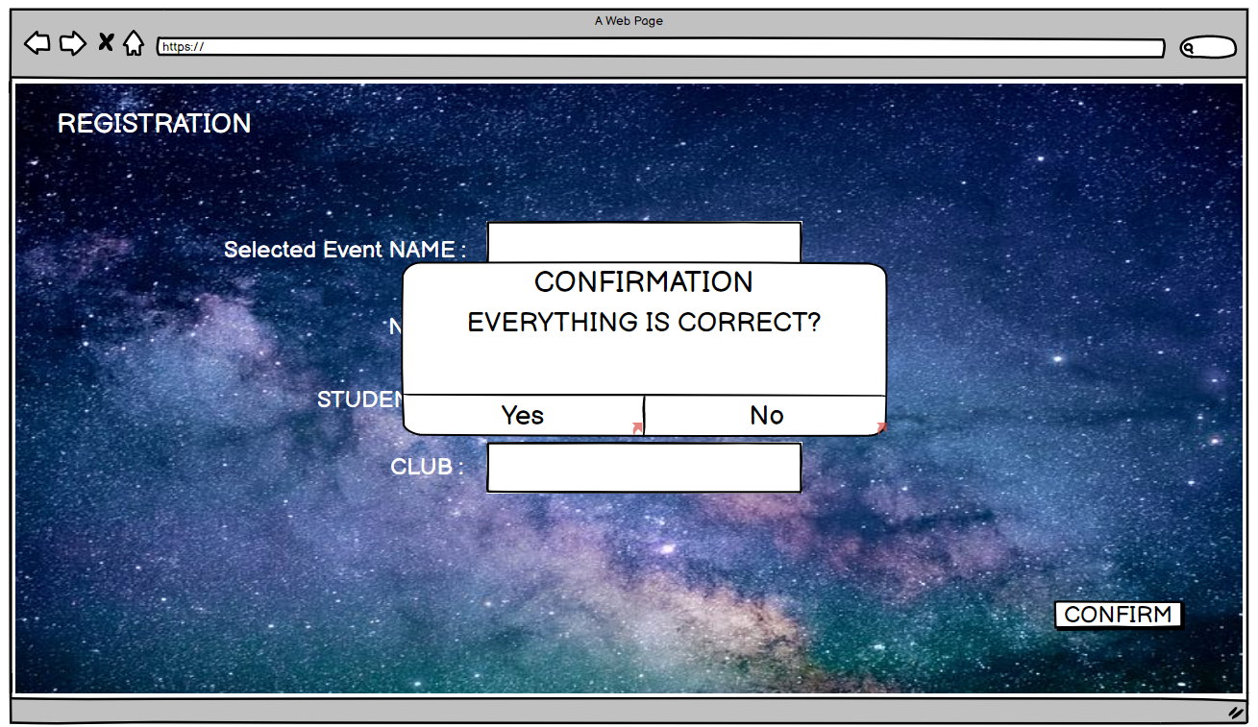

Question 12: How to like or dislike other people’s review?

Review Page

